**Module 5: Critical Thinking Assignment**

Brady Chin

Colorado State University Global

CSC500-1: Principles of Programming

Dr. Steven Evans

June 16th, 2024

**Module 5: Critical Thinking Assignment**

This weeks critical thinking assignment consists of two parts. In the first part we are tasked with prompting the user to enter a number of years then use nested loops to collect data and calculate the average rainfall over that period. In the second part, we prompt the user to enter the number of books they have purchased and award points based off how many books they’ve purchased.

**Part 1**

I enjoyed coding part 1. It was great practice on using nested loops to iterate through different lists and ranges. It was tedious testing the code afterwards and having to enter 12 values for each year that the user had entered. This could get demanding when the number of years increases. It made me think about creating a script that will test Part 1 by testing different scenarios like an increased number of years or invalid user inputs. The script will then return which tests passed or failed.

**Part 2**

I found Part 2 to be pretty simple. It was great practice using the AND operator. I think that we can use Part 2 as a template for more complicated point awarding systems. For example, the points awarded to each racer and team in Formula 1. This will be the same concept except on a larger scale with more entries.

**GitHub Repository and Pseudocode**

GitHub Repository: [LINK](https://github.com/bradychin/csu-global-projects/tree/50a4a25d3bc6e69cd3cdbfd03972e21524959c41/Principles%20of%20Programming/Critical%20Thinking%20Assignments/Critical%20Thinking%205)

Part 1 Pseudocode: [LINK](https://github.com/bradychin/csu-global-projects/blob/50a4a25d3bc6e69cd3cdbfd03972e21524959c41/Principles%20of%20Programming/Critical%20Thinking%20Assignments/Critical%20Thinking%205/CT5Part1Pseudocode.txt)

Part 2 Pseudocode: [LINK](https://github.com/bradychin/csu-global-projects/blob/50a4a25d3bc6e69cd3cdbfd03972e21524959c41/Principles%20of%20Programming/Critical%20Thinking%20Assignments/Critical%20Thinking%205/CT5Part2Pseudocode.txt)

**Screenshots**

Par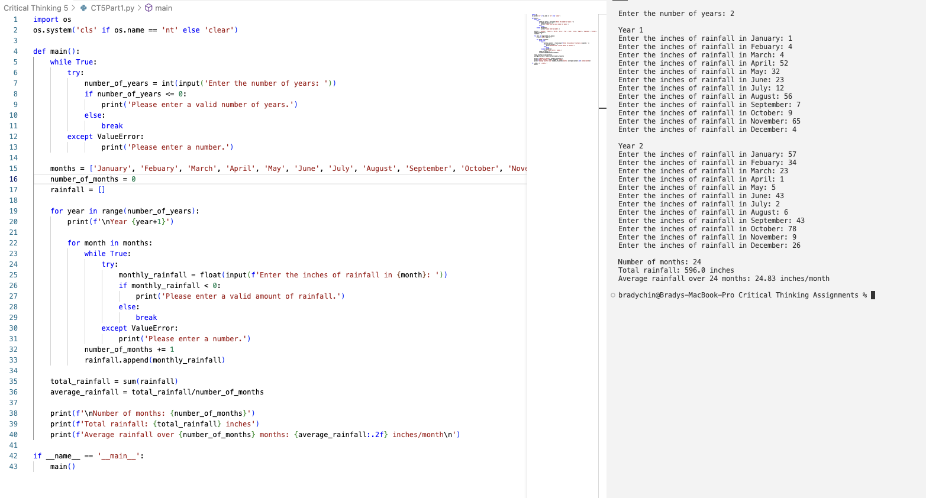t 1:

Part 2: